FINAL EXAMINATION
TIME ALLOWED: 90’
Subject: Linear Algebra. No books allowed.

1/ Find the matrix  such that 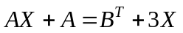, where 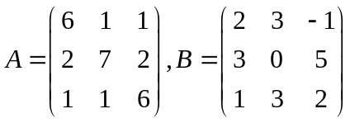.

2/ Find all real value(s) m, given that the matrix 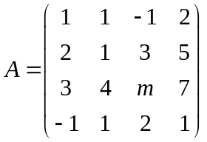 is invertible.

3/ Let 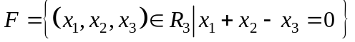 and
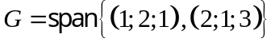 be two subspaces of the vector space 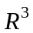.
Find one basic and a dimension of the intersection 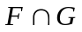.

4/ Given the inner product in as follow:
and the subspace 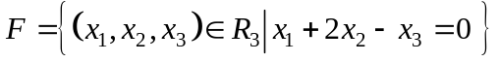.
Find one basic and a dimension of the orthogonal complement 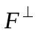.

5/ Let 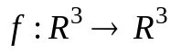 be the linear transformation.
Assume that .
a/ Compute 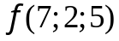.
b/ 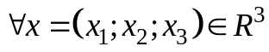, find 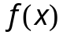.
6/ Let be the linear transformation and 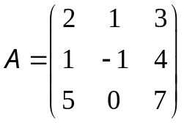 be the matrix of the
mapping 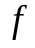 in the basis 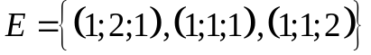. Compute 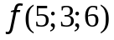.

7/ Compute 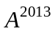, given that 

  

